­­­

NHS Credential Management v1.4.2.0

Administrators Guide

­­­­­

|  |  |  |  |
| --- | --- | --- | --- |
| Document filename: | **NHS Credential Management v1.4.2.0**  **Administrators Guide** | | |
| Project / Programme | **Platforms** | Project | **IAM** |
| Document Reference | **NHS Credential Management v1.4.2.0**  **Administrators Guide** | | |
|  |  | Status | **​​Live​** |
| Owner | **Phil Gill** | Version | **​​1.0** |
| Author | **Ashley Harris** | Version issue date | **​​24/07/2024** |

**Contents**

Application Support 4

Audience 4

NHS Credential Management v1.4.2.0 – What’s New * 4

Introduction to NHS Credential Management 4

Software & Documentation 5

End User License Agreement 5

What’s New in Idemia Series 9 Smartcard 5

Address on the back of the smartcard 6

Software Requirements 6

Functional Changes to Series 9 Smartcards 6

Series 9 Smartcard Printer Set Up 7

System Requirements 9

Operating Systems 9

Other components 9

Environments 9

Browser Compatibility 9

Legacy 10

Middleware / Identity Agent 10

Deployment 10

Overview 10

Installing NHS Credential Management 10

Silent Installation 13

Starting NHS Credential Management 13

System tray notifications 13

Directory Structure 13

Log Paths 13

NHS Port Service 14

Uninstallation 14

Configuration 15

Internet Options Settings 15

Group Policy Settings 17

Chrome and Edge Cookie Settings 19

Troubleshooting 22

.NET 4.8 Missing 22

Multiple Versions Installed 22

NHS Port Service Not Running 22

Windows credential prompt while accessing web applications 23

NHS Port Service start-up failure on VDI environment 29

No Idemia PIV Minidriver 29

Locked Smartcard (Series 9 Only) 30

Support 30

## 

## Application Support

****** Please note that Windows 7/8 are no longer supported operating systems - We advise organisations to update to Windows 10 /11 ******

## Audience

The document is aimed at IT Managers, IT Administrators, suppliers of desktop build and support services, and any other person who has responsibility for installation, configuration, support and management of NHS Credential Management.

## NHS Credential Management v1.4.2.0 – What’s New *

This release of NHS Credential Management has resolved and introduced the below:

* SHA2 Support for prescription signing on smartcards

*(OT Middleware NEEDS to be present to enable this on Series 8 smartcards)*

* Resolved high CPU usage issues on multi-user machines (VDI, Terminal Services)

*(This issue was caused by the legacy Gemalto middleware)*

* Additional enhancements to ensure **support** of CMS operations with VDI and Terminal Services
* Resolved an issue where RA Repair followed by RA Renew of a Series 8 card caused problems due to a caching bug in Series 8 middleware.
* Updated installer to create the NHSEnrollment registry key if it isn’t detected.

## Introduction to NHS Credential Management

With the release of NHS Credential Management, the dependency of CIS on Java applets and the Internet Explorer browser is removed.  
  
Specifically, all components of CIS

* + URS
  + CMS
  + EPR
  + BATCH
  + Portal
  + Self Service Unlock

are now accessible from Chrome, Edge, Opera and most other modern browsers - with the notable exceptions of Firefox (which isn’t supported at all) and Internet Explorer (users of which can continue using Java applets as they have until now).

The NHS Credential Management installation package installs the NHS Credential Management application itself and also the NHS Port Service which is a requirement for using NHS Credential Management.

NHS Credential Management will work with all Identity Agents and all smartcards. It is an additional component which allows extra functionality. It does not require any changes to the system (other than possibly a minor change to Internet Options settings as discussed in the Configuration section of this document).   
  
In other words, everything in the Identity Agent installation guide still applies (for whichever Identity Agent is in use). NHS Credential Management is not involved in the actual process of authentication. Its job, for many applications, is simply to allow communication between modern browsers and the Identity Agent. However, it also contains most of the logic of the Card Management System and other CIS applications which was previously contained in Java applets.

Note - the removal of the dependency of all CIS applications on Java does not in itself mean that Java can be removed from the end user’s machines. This can only be done once *all* browser-based Spine applications used on the machine have changed their code to utilise NHS Credential Management rather than the old Java applet that they currently use to communicate with the Identity Agent. So, in some cases, it might be immediately possible to remove Java, if the only browser-based Spine applications in use are CIS applications. In other cases, it might be a long wait until third-party software is changed.

# Software & Documentation

All software and administrative documentation can be downloaded from <https://nww.digital.nhs.uk/dir/downloads/> (Requires HSCN)

The latest Warranted Environment Specification (WES) can be downloaded from   
<https://digital.nhs.uk/services/spine/spine-technical-information-warranted-environment-specification-wes>

# End User License Agreement

The license agreement for this software is available to read upon installation.   
The NHS Credential Management software and the accompanying documentation are wholly owned by NHS England.

Copyright (C) 2024 NHS England - All Rights Reserved

## What’s New in Idemia Series 9 Smartcard

The Idemia Series 9 card does not have any major visual differences and looks exactly like the Oberthur Series 8 smartcard.

There are minor differences listed below:

## Address on the back of the smartcard

The address at the back of smartcards is updated with the latest Address.

## Software Requirements

### Idemia PIV mini driver

The Idemia PIV mini driver should be present by default if Microsoft updates are allowed, if not the user can download the component from the following path:

<https://na.idemia.com/wp-content/uploads/2021/09/CivMinidriver-1.2.8.zip>

All users should be able to authenticate without any issue if the Microsoft PIV mini driver is installed.

### NHS Credential Management software

* Latest NHS Credential Management software needs to be installed to support Series 9 smartcard functionality. Users can download the latest NHS Credential Management from the DIR website.

## Functional Changes to Series 9 Smartcards

All applications which allow users to Issue/Issue and Print smartcards will only allow smartcards to have a 6-8-digit numeric passcode. All other existing smartcard passcodes will work as expected.

During an, Unlock by an RA, Change passcode, Self-Change passcode, Self Service unlock, and Repair smartcards operations the CIM application will force to use the 6-8-digit numeric passcode for existing supported 05,06,08 smartcards.

## Series 9 Smartcard Printer Set Up

Please see the matrix set out below for printer set ups and the relative configurations:

***Please note that the below matrix is only for use with Series 9 smartcards ONLY.***

|  |  |  |  |  |  |  |  |  |
| --- | --- | --- | --- | --- | --- | --- | --- | --- |
|  |  |  |  | **Reader Driver** | |  | **Supported Method of Printing** | |
| **Device** | **Printer Driver** | **Firmware** | **Reader Manufacturer** | **Windows 10** | **Windows 11** | **Reader Firmware** | **Contacted** | **Contactless** |
| DoH v2 – 5122 Reader | [**v3.0.2.967**](https://support.magicard.com/solution/driver/#attachments) | [**JV7.51**](https://support.magicard.com/solution/enduro-firmware/) | OMNIKEY | HID Omnikey CCID 2.3.4.121 | HID Omnikey CCID 2.3.4.121 | ----- | ü | û |
| DoH v2 – 5x21 Reader | OMNIKEY | Microsoft Usbccid Smartcard Reader (WUDF) | Microsoft Usbccid Smartcard Reader (WUDF) | ----- | ü | û |
| DoH 300 | [**v15.57**](https://support.magicard.com/solution/magicard-rio-pro-360-firmware/) | Elatec | Elatec v5.3.0.31 | Microsoft Usbccid Smartcard Reader (WUDF) | TWN4/B1.08/NPF3.23/M1SC1.62 | û | ü |

Please note the following advice and guidance on the configurations and their relative links to downloads:

* If you are using Windows 11, the default Microsoft Usbccid Driver will be installed to allow you to perform the Issue and Print operation via **Contactless** on a DoH 300.
* The DoH 300 has an alternate smartcard reader inside it. If the driver is not installed through Microsoft Update (automatically), then please download the Elatec - USB - 5.3.0.31 from here: <https://www.catalog.update.microsoft.com/Search.aspx?q=elatec> and install it manually.
* For the DoH v2 5122 Reader and DoH 300 (v2) printers the most recent driver has been tested and can be used. This is either installed via Microsoft Update (automatically) or you can download and manually install this from here: <https://support.magicard.com/solution/driver/>   
    
  ***Kindly be aware to avoid utilising outdated drivers, as this has undergone testing to ensure backward compatibility with DoH v2.***
* The printer firmware serves as a reference solely to indicate successful testing up to the present version; earlier versions remain compatible.
* DoH v2 - 5x21 Reader: For Series 9 to work with the printer, ensure the default Microsoft driver (Microsoft Usbccid Smartcard Reader (WUDF) is installed, to achieve that, please follow these steps:
  + - 1. Go to Device Manager
      2. At the top select ‘View’ and ‘Show hidden devices’ (this allows you to see previously connected devices that are in a disconnected state)
      3. Under the Smart card reader section
      4. Select the Smart card reader (OMNIKEY 5x21)
      5. Click on uninstall the device.
      6. Check the delete driver checkbox and uninstall the same.
      7. Once done, please unplug both the printer USBs from the machine, then connect it again and test.

***\*\*\* Windows Updates Definition -******Windows can automatically check if there are drivers available for new devices that you connect to your computer.***

# System Requirements

## Operating Systems

NHS Credential Management requires a Windows operating system from the list stated below (other operating systems may work but are not warranted).

The following operating systems are warranted for use:

* + - * Windows 10 (x64) – excluding Windows 10 (x64) – IOT
      * Windows 11 (x64)

## Other components

|  |  |  |
| --- | --- | --- |
| Component | Description | Minimum Version |
| .NET Framework | The programming infrastructure created by Microsoft for building, deploying, and running applications and services that use .NET technologies. | Microsoft .NET 4.8. |

## Environments

The use of NHS Credential Management under other environments such as VDI / Terminal Services is also supported.

Note: CMS (Card Management System) operations are now supported on VDI / Terminal Services.

## Browser Compatibility

Below is the list of supported browsers for NHS Credential Management:

* Chrome
* Edge
* Opera
* Firefox

NHS Credential Management does NOT work with Internet Explorer. Anyone wishing to continue using Internet Explorer must continue using Java applets with the current architecture. (Note: installing NHS Credential Management does not prevent anyone from continuing to use existing applications with Internet Explorer – they just won’t be using NHS Credential Management).

NHS Credential Management does NOT work with the old pre-Chromium versions of Edge. The new version of Edge based on the Chromium engine released after 15th Jan 2020 is supported.

NHS Credential Management *should* work with most other modern browsers (i.e. except for Internet Explorer), although these have undergone less testing and so are not officially supported.

# Legacy

## Middleware / Identity Agent

The presence of Gemalto and Oberthur Middleware and an Identity Agent are still required in order to log into Spine using Series 8 Smartcards. NHS Credential Management is an additional component to the system to allow the removal of Java applets from browser-based Spine applications. It does not replace anything else.

Identity Agent from v2.2.x and above are recommended to be used. Other versions of Identity Agent may work but are not supported or recommended for use with NHS Credential Management.

# Deployment

## Overview

NHS Credential Management is packaged as a discrete .msi and includes the components:

* NHS Credential Management
* NHS Port Service

Installation is a straightforward process using the Windows Installer framework (msiexec). **NOTE:** installation or uninstallation of the program does require administrative rights.

Other dependencies as listed in the System Requirements section must be installed separately and before the installation of the NHS Credential Management package (i.e. .NET 4.8).

## Installing NHS Credential Management

**NOTE:** Admin rights are required to install or uninstall NHS Credential Management.

To install NHS Credential Management, double-click on the .msi file in the folder the file was downloaded to and follow the prompts by clicking ‘Next’ on each window as required.

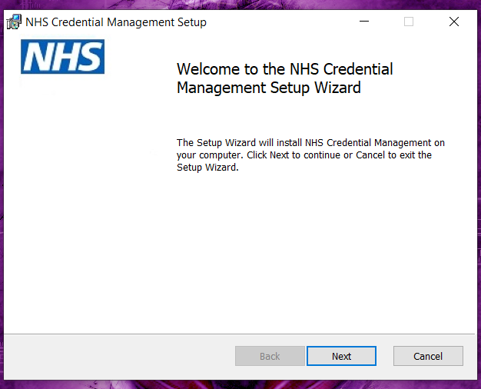

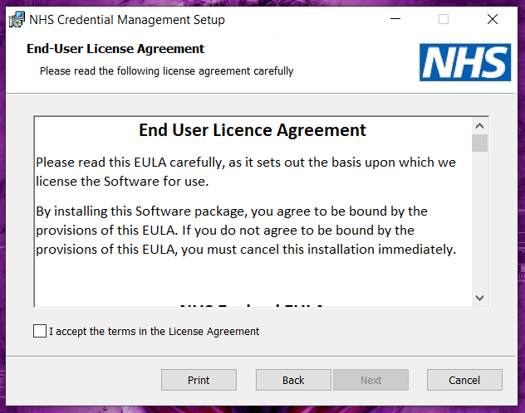

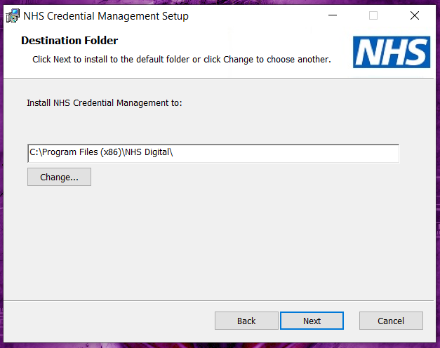

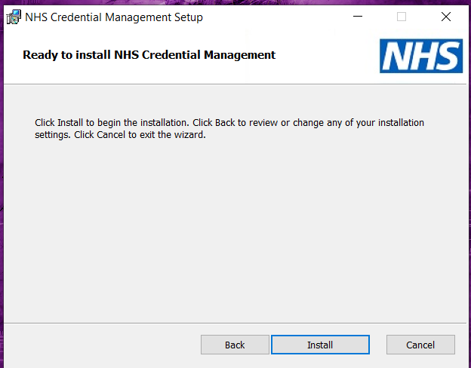

.

Click ‘Install’ to continue. Select ‘Yes’ should any prompts be given from User Account Control regarding changes to the computer

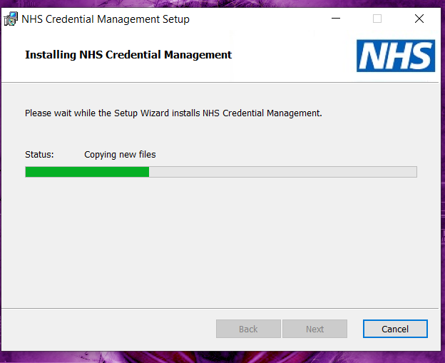

Click ‘Finish’ once the installation has completed to close the installation dialogue box.

Once NHS Credential Management has been installed, an icon will be placed in the Programs | NHS Credential Management area of the Start Menu. On Windows 10 devices, an icon will also be placed on the Applications screen.

**NOTE:** NHS Credential Management does not automatically start after installation but will automatically start on a subsequent user login or machine restart. For immediate use after installation, launch the program in the appropriate manner.

## Silent Installation

NHS Credential Management supports a silent installation using standard deployment toolsets that recognise .msi packages, or if installing via a script the following command line can be used:

%SystemRoot%\System32\msiexec.exe /i "NHS.CredentialManagement.Setup-1.4.2.0.msi" /qn

## Starting NHS Credential Management

To start NHS Credential Management:

* + Windows 10/11: Click on the Windows Icon, search, ‘NHS Credential Management’

NHS Credential Management does not automatically start after installation but will automatically start on a subsequent user login or machine restart.

## System tray notifications

An icon will be visible in the system tray when NHS Credential Management is running. The program can be closed by right clicking on this icon and selecting Close. Right clicking and selecting Status will show the currently installed version.

## Directory Structure

NHS Credential Management will be installed into the following location

64bit machines

C:\Program Files (x86)\NHS Digital\

* C:\Program Files (x86)\NHS Digital\NHS Credential Management
* C:\Program Files (x86)\NHS Digital\NHS Port Service

## Log Paths

The NHS Port Service logs can be found under the below path:

C:\ProgramData\HSCIC\NHS Port Service

NHS Credential Management logs can be found under the below path:

C:\Users\{username}\AppData\Local\HSCIC\NHSCredentialManagement

## NHS Port Service

As part of the NHS Credential Management installation, the NHS Port Service will be installed on a machine and will automatically start. This service is required for NHS Credential Management to function correctly and should not be stopped or barred from executing.

## Uninstallation

**NOTE:** Admin rights are required to install or uninstall NHS Credential Management.

To uninstall NHS Credential Management, go to Control Panel => Programs and Features and double-click on NHS Credential Management file in the panel.

Click ‘Yes’ to continue process of uninstallation of setup. Select ‘Yes’ should any prompts be given from User Account Control regarding changes to the computer.

Do not press Cancel button until it finishes the process. Once NHS Credential Management has been uninstalled, the icon will be removed from the Programs | NHS Credential Management area of the Applications screen on a Windows 10/11 machine.

**NOTE:** The NHS Port Service will be stopped and removed from the machine during the process of uninstallation.

# Configuration

## Internet Options Settings

**NHS Credential Management should work without any configuration on Windows 8 and Windows 10 if the default settings have not been modified.**  
  
**On Windows 7 a change to the default settings is required.** If settings have been changed on Windows 8 and 10, then the same change may be required.

To check that Windows is configured as required and make the necessary changes if not,

navigate to Control Panel >> Internet Options >> Security >> Local Intranet >> Sites

The above are the default settings on Windows 8 and Windows 10. If ‘Automatically detect intranet network’ is unticked and the other three checkboxes are checked as above, then no configuration should be required for NHS Credential Management.

On Windows 7 however, the default settings look as follows, with the ‘Automatically detect intranet network’ checkbox checked and the others not.

If that is the case then NHS Credential Management will not work without changes.

There are two potential ways to resolve this:

1. Untick ‘Automatically detect intranet network’ and check the other three boxes so that it looks like the default settings in Windows 8 and 10.

2. Add http://locahost into the sites list for the Local intranet zone.  
This is achieved by clicking on the ‘Advanced’ button, and then adding http://localhost.

## Group Policy Settings

There are some Chrome and Edge specific group policy settings which can block NHS Credential Management from working if they have been set. The error you will see if this is happening is the generic error saying that NHS Credential Management isn’t installed or isn’t running:

Clearly, there are multiple more straightforward possible reasons for seeing the above error.  
But if NHS Credential Management and the NHS Port Service *are* running, and in particular if everything works in one browser (e.g Edge), but not in another (e.g Chrome). Then it is worth checking the group policy settings.

To see the Chrome specific group policy settings applied to your machine, browse to chrome://policy using your Chrome browser.

To see the Edge specific group policy settings applied to your machine, browse to edge://policy using your Edge browser.

**Note: Changes to group policy settings will need to be made by your IT Administrator.**

**For Chrome, the setting which causes a problem is:**

*BlockThirdPartyCookies*  
If this is set to true then NHS Credential Management will fail to work in Chrome.

Two solutions to make it work:  
- You can set BlockThirdPartyCookies to false, but that's a sledgehammer to crack a nut and isn't necessary.  
- Better, if you add "localhost" to the CookiesAllowedForUrls group policy setting, then this will solve the problem.

More details:  
<https://chromeenterprise.google/policies/#BlockThirdPartyCookies>

<https://chromeenterprise.google/policies/#CookiesAllowedForUrls>

**For Edge, again the setting which causes a problem is:**

*BlockThirdPartyCookies*If this is set to true then NHS Credential Management will fail to work in Edge.

Two solutions to make it work:  
1. You can set BlockThirdPartyCookies to false, but that's a sledgehammer to crack a nut and isn't necessary.  
2. Better, if you add "localhost" to the CookiesAllowedForUrls group policy setting, then this will solve the problem.

More details:  
<https://docs.microsoft.com/en-us/deployedge/microsoft-edge-policies#blockthirdpartycookies>

<https://docs.microsoft.com/en-us/deployedge/microsoft-edge-policies#cookiesallowedforurls>

## Chrome and Edge Cookie Settings

The same issue seen in the section above on group policy can also be caused by the cookie settings in Chrome and Edge if they have been changed from the defaults. Specifically, the browser needs to allow cookies for localhost.

**In Chrome:**

1. Click the “Customize and Control” button: on the top-right corner of the chrome browser window you will see the Customize menu icon.  
   A screenshot of a browser

   Description automatically generated
2. Click on the “Settings” menu item  
   A screenshot of a computer

   Description automatically generated
3. Select Privacy and security and click on Cookies and other site data.  
   A screenshot of a computer

   Description automatically generated

By default the “Block third-party cookies in Incognito” option is set. That is fine (as long as not using Incognito mode obviously). However, on some machines some people have changed the setting to either “Block third-party cookies” or “Block all cookies”. In that case, NHS Credential Management will not work.

The fix is to either:

* select the “Block third-party cookies in Incognito” option
* select the “Allow all cookies” option
* Add “localhost” into the “Sites that can always use cookies” section, and check the box saying “including third-party cookies on this site”

**In Edge:**

1. In the top-right corner of the Edge browser window you will see the Customize menu icon.

1. Click on the “Settings” menu item and Select ***Cookies and site permissions*** from left hand panel

1. Select Manage and delete cookies and site data.

If “Block third-party cookies” is set, then NHS Credential Management won’t work without changes.

The options are to:

- Change the setting to “Allow sites to save and read cookie data” (which is the default option)

- Click Add in the Allow section, add localhost, and tick the checkbox saying “Include third-party cookies on this site”.

# Troubleshooting

## .NET 4.8 Missing

When attempting to install NHS Credential Management, the following error may occur:

This is caused when the machine does not have .Net Framework 4.8 installed.

To resolve this, install the .Net Framework 4.8 and try again.

## Multiple Versions Installed

NHS Credential Management does not currently remove any previously installed versions prior to installation of a new version of the software. Instead, attempting to run both versions simultaneously will display an error saying that the application is already running.

Should multiple versions be inadvertently installed, remove all installations of NHS Credential Management. Once all existing installations have been removed, the correct version of NHS Credential Management can then be installed.

## NHS Port Service Not Running

If the NHS Port Service is stopped and a user attempts to access Spine or any application, the following error may occur:

To resolve this issue, navigate to Services with admin privileges and search for NHS Port Service. Start the NHS Port Service and then NHS Credential Management should start without issues.

It is mandatory to keep the NHS Port Service running always while using NHS Credential Management. So, to avoid this error it is recommended to never stop the NHS Port Service manually.

## Windows credential prompt while accessing web applications

If this prompt is seen, the machine is not configured correctly to use NHS Credential Management.

**Go to the Configuration section of this guide and follow the instructions there.**

If the issue is still not resolved, then use the following steps:

**Local Intranet Zone Settings**

1. Click on the *Sites* button and verify the checkboxes are as shown in the image below

1. Click the *OK* button
2. Click on the *Custom Level* button as shown in the image

1. Scroll to the bottom in the *Settings* pane and verify the following radio button as shown in the image below and click on the *OK* button.

This should be all that is required for NHS Credential Management to work.  
If the issue is persisting, then check the settings in the Trusted Sites zone:

**Trusted Sites Zone Settings**

1. Select the *Trusted Sites* zone, and click on the *Sites* button as shown in the image below

7a. Check to see if any of the following entries are there in the websites list. Don’t modify the list.

* 1. <https://localhost>
  2. [http://localhost](http://localhost/)
  3. localhost

These entries are NOT needed for NHS Credential Management. If none of them are present, then move to step 8. However, if one or more than one of these entries are in place for other reasons, then the change specified in steps 7b and 7c is required.

7b. Only required if specified in step 7a. Click on the *Custom Level* button as shown in the image

7c. Only required if specified in 7a. Scroll to the bottom in the *Settings* pane and ensure the following radio button is as shown in the image below and click on the *OK* button.

If a change was made in step 7, retry using NHS Credential Management at this point. If the issue is persisting, then check the settings in the restricted sites zone:

**Restricted Sites Zone**

1. Select the *Restricted Sites* zone, and click on the *Sites* button as shown in the image below  
   A screenshot of a computer screen

   Description automatically generated
2. If any of the following entries exist in the websites list, remove them and click the *OK* button.
   1. <https://localhost>
   2. [http://localhost](http://localhost/)
   3. localhost

## NHS Port Service start-up failure on VDI environment

On a VDI system, if the user is prompted with the above exception while the system is booting up and the user is using NHS Credential Management version less than 1.1.0.0 then perform the solution as mentioned below. If using NHS Credential Management 1.1.0.0 or higher, this issue is resolved.

**Solution**

1. Stop the NHS Port Service.
2. Delete the following files.
   1. C:\Program Files (x86)\NHS Digital\NHS Port Service\PortStore.txt
   2. C:\Program Files (x86)\NHS Digital\NHS Port Service\DomainList.txt
3. Recreate the VDI image.

## No Idemia PIV Minidriver

Smartcard not authenticating and the Identity Agent is displaying an error:

**Guidance**

Download the latest Idemia PIV Minidriver, install it with administrative rights, and restart the system. Make sure the PIV Minidriver is present on the following system path:

**Installation Method**

* Microsoft Update

C:\Program Files (x86)\CivMinidriver

* MSI File

C:\Windows\System32\CivMinidriver64.dll

Path for Idemia PIV Minidriver installation media:

<https://na.idemia.com/wp-content/uploads/2021/09/CivMinidriver-1.2.8.zip>

## Locked Smartcard (Series 9 Only)

If you fail to enter the correct passcode via the contactless method, you will reach your maximum retries after 7 failed attempts. Should this happen, you can try an additional 3 attempts via contacted to recover the smartcard. If this fails, then you will need to seek help from your local RA to unlock your smartcard.

By default, the values set for contacted attempts is 10 and 7 via contactless.

# Support

**For further support or more information, please use one of the following:**

Raise a ticket via the [NHS Digital Customer Portal](mailto:NHS%20Digital%20Customer%20Portal,) or email [ssd.nationalservicedesk@nhs.net](mailto:ssd.nationalservicedesk@nhs.net)

Telephone contact 0300 303 5035

**Alternatively, write to:**

Iamplatforms@nhs.net